FSC On the Map.

Workflow Document and User Guide

Version 1.0

Department in charge | Data, Analytics, Evaluation and Learning – DAEL
Created by | Andrés Felipe Ramirez
Version | 1.0
Last update | July, 2019

Table of Contents
1. FSC OKR Access 5
2. FSC on the Map collection 8
3. Submissions 10
4. Data Validation 17
Appendix 1: GIS data structure and template 18

As part of the FSC on the Map project, we are geographically displaying the boundaries of some certified forests. These are provided on an entirely voluntarily basis by our certificate holders or FSC partners.
This document outlines the workflow of the complete contribution process as well as serves as a user guide showing each step with detailed information.
If a Certificate Holder or FSC Partner wants to contribute with new certified locations, it must follow the steps described below. Figure 1 and 2 show a general and detailed workflow of the contribution process respectively.

Figure 1. General Workflow. Open FSC Contribution process
Phase III - Validation/Publication
Phase I - Authentication
Phase II - Submission
Contributor
Website
Collections
Item description
GIS Files
License agreement
Complete Submission
Validation of Data: Approval/Rejection
Data Publication
FSC on the Map

Figure 2. Detailed Workflow. Open FSC Contribution process
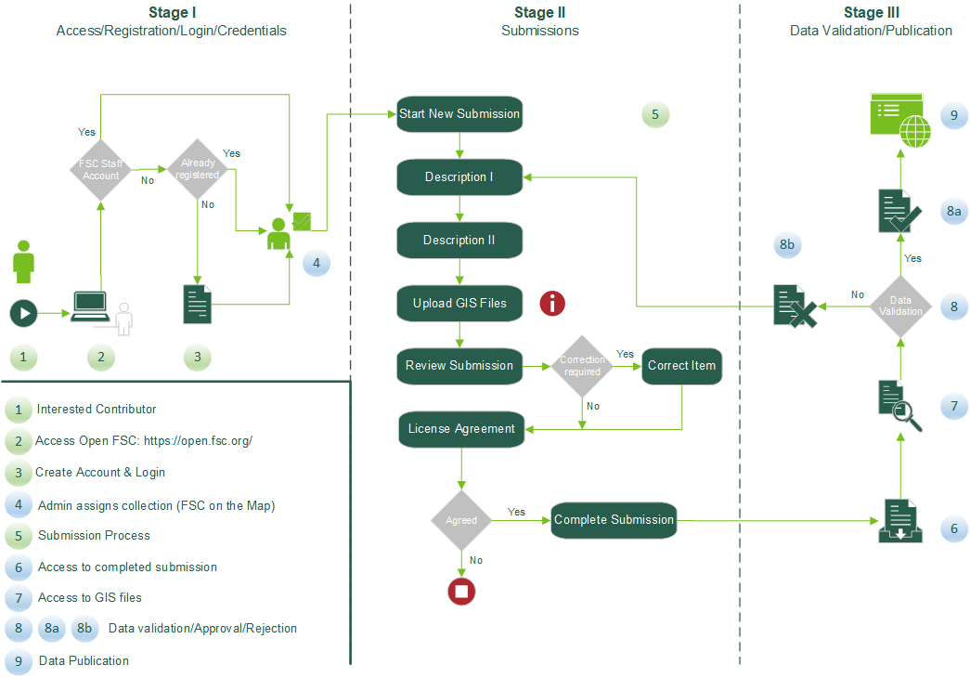

.

- FSC OKR Access

  - Access open FSC platform through the following link: https://open.fsc.org/
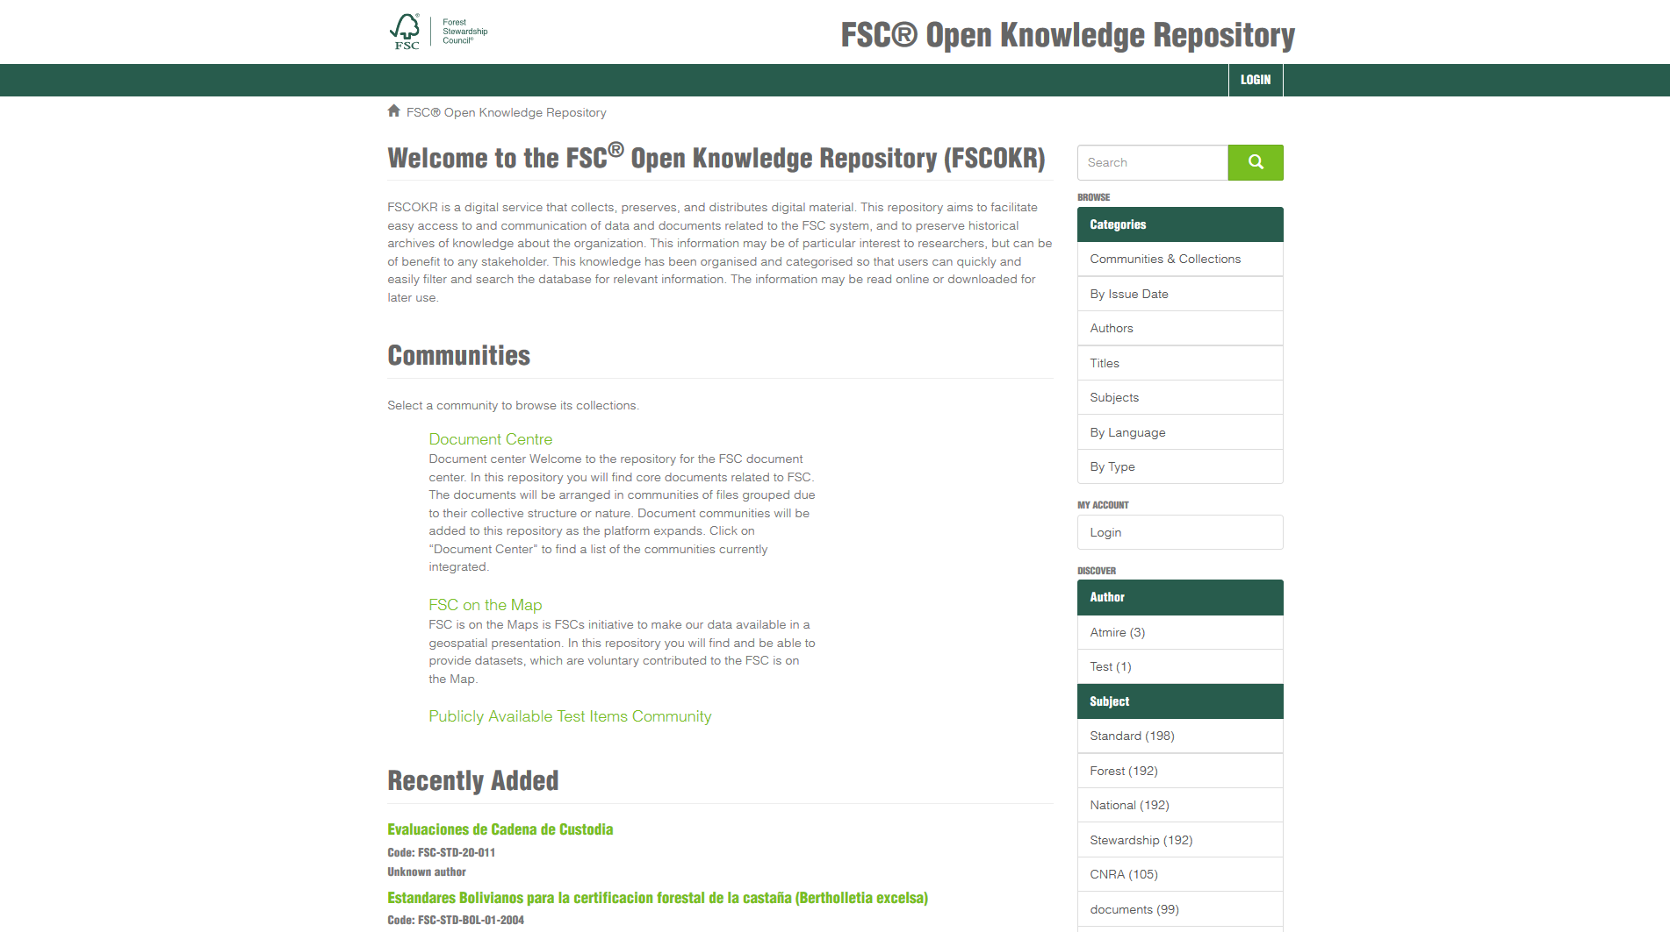

    - Click on “Login” button located at the upper-right side of the screen

    - Click on the “Login or Register with FSC” link
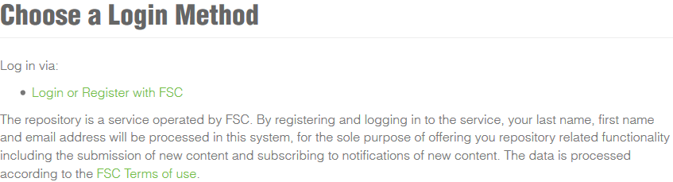

  - Login/Sign up

If you own an FSC Account:

    - Click on “Continue”.
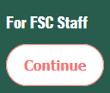

    - Sign in using your FSC account details.

If you don’t have an FSC account and have not registered before:

    - Click on “Sign up now” option.

    - Enter your email address and click on “Send verification code”. You will receive an email with a confirmation code, type it into the text box and click on “Verify code”. If the code is correct you will get your email address verified.

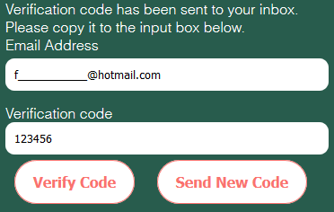

    - Fill up all the required data and click on “Create”

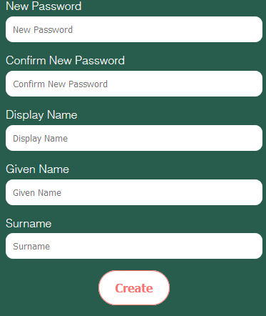

If you don’t have an FSC account and have already registered:
    - Enter your registered email address and password. Click on “Sign in”
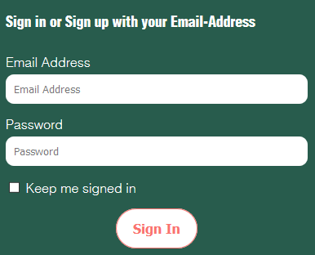

Once you have correctly registered/signed in, you will be directed to the open FSC website main page.
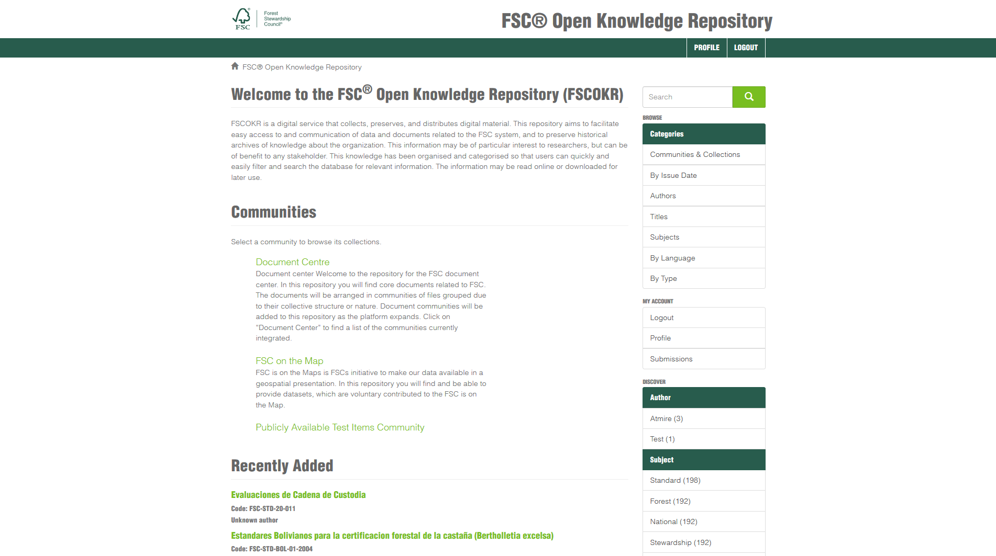

- FSC on the Map collection

OKR works with collections, and each collection is related to a specific topic. This document only explains how FSC on the map collection works. FSC on the Map is FSCs initiative to make our data available in a geospatial presentation. In this repository you will find and be able to provide datasets, which are voluntary contributed.
  - Click on “FSC on the Map”. All the available collections are displayed.
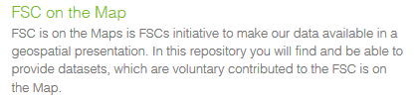

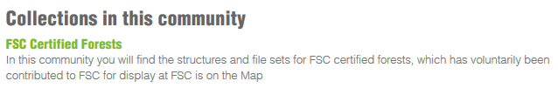
  - Click on “FSC Certified Forests”. The FSC Certified Forests page displays.

It shows a general overview of the contribution process as well as access to the GIS data template.
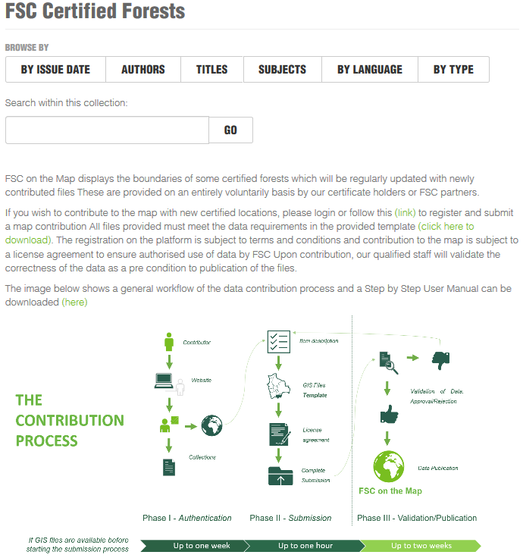

  - Click on “Click here to download” to get access to the GIS data template (shapefile). For more details please refer to Appendix 1: GIS data structure and template.

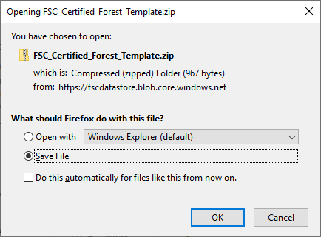

- Submissions

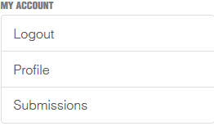
  - Click on “Submissions”. A list of unfinished submissions is displayed. Click on “Start another submission”.

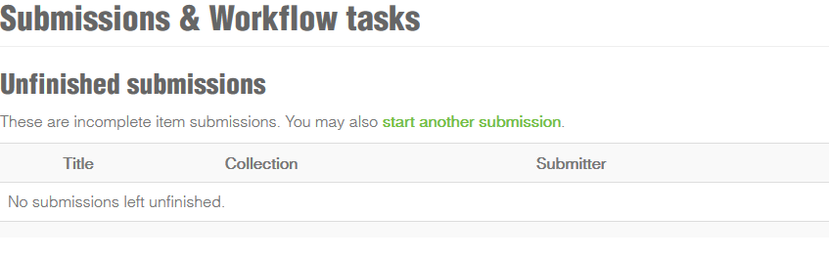

  - In the dropdown list select FSC on the map -> Certified Forests and click “Next”.

  - A screen with description information is displayed. Mandatory fields are tagged with a * symbol. Fill out the required information. Click on “Next”.
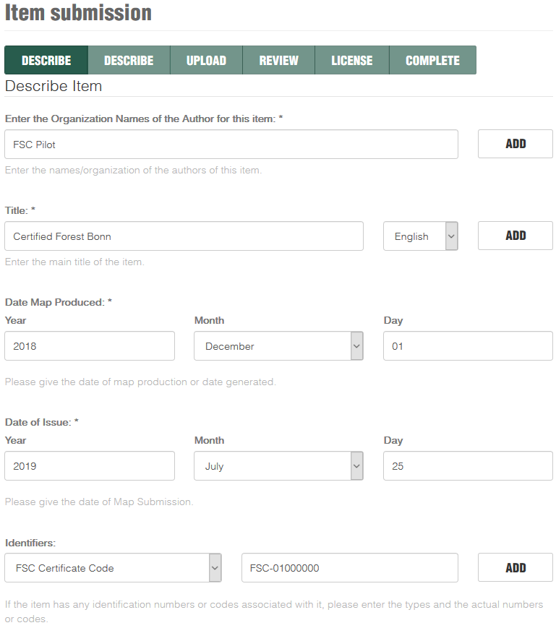
.

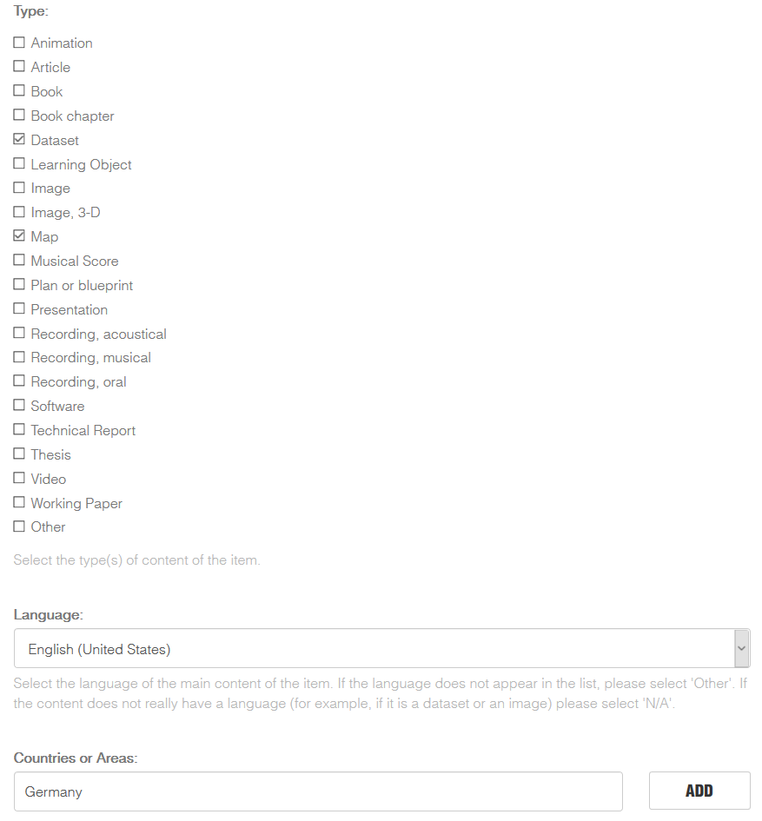

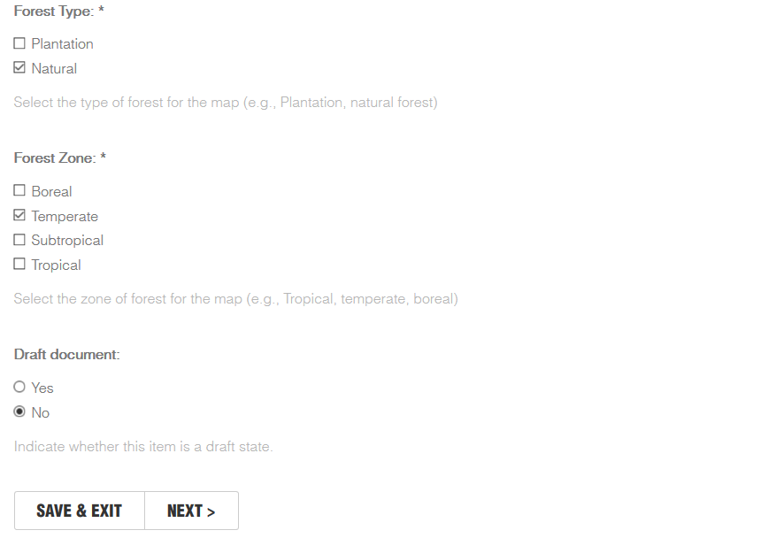

  - An additional description screen is displayed. Fill the required information and click on “Next” to continue with the uploading process, or “Save and Exit” to continue later.
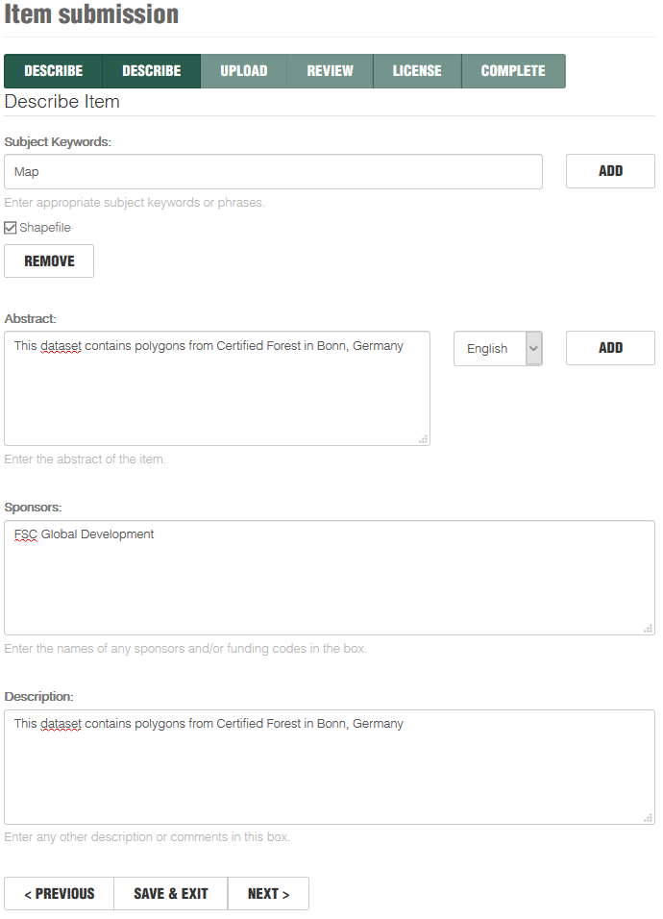

  - The uploading screen displays. Click on “Browse” and select the file you want to upload.

- When uploading shapefiles be sure to add the necessary files to the .zip or .rar file
- The required minimum component files of a shapefile are: .shp, .shx, .dbf and .prj
- Optional component files are: .cpg, .fix, .qix, .sbn, .shp.xml
- Be sure the file structure matches the provided template (field names, field types, field lengths), otherwise, the submission will be rejected

- Click on “Upload file & add another” to upload more than one file.
- Click on “Save and Exit” to continue the upload later.
- Click on “Next” to finish the upload.
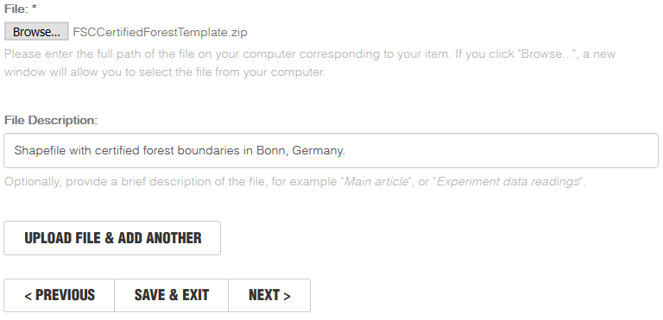

  - A list with all the uploaded files is displayed. It allows edition and removal. Click “Next” to continue the submission process.
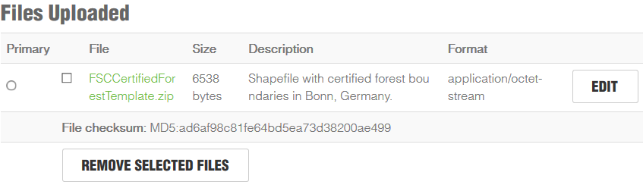

  - A review of the submitted data is display. Click in “Correct one of these” in case any modification to the information is required, otherwise, click “Next” to continue the submission process.
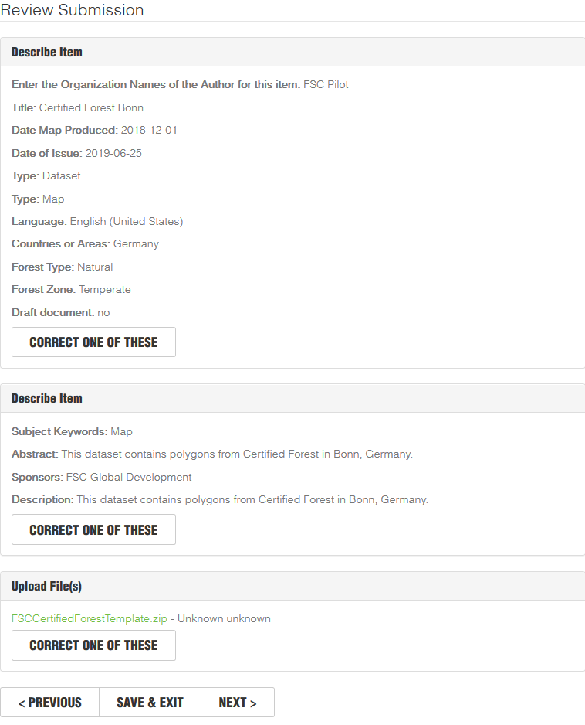

  - Distribution License. Check the “I grant the license” box to agree with the terms and conditions described in the license. Click on “Complete Submission” to complete the submission process or on “Save and Exit” to finish it later.
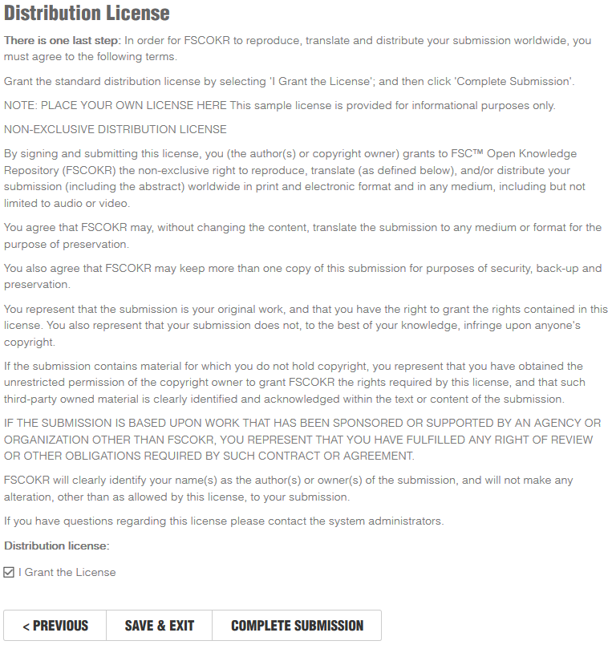

- Data Validation

Once the submission is completed, it will be moved to the revision queue. The attached shapefile will be checked against the FSC defined data structure (see Appendix 1: GIS data structure and template); if is correct, the submission is approved. If the reviewing step shows inconsistencies on the data structure or the geometry, it is considered as not suitable for inclusion, and will be rejected.
When a submission is approved, it will be tagged as accepted and displayed in the Archived Submissions record and its corresponding GIS data attached to the existing core dataset becoming available in the FSC Certified Forests Web Map.
When a submission is rejected, it will be returned to the Unfinished Submissions list until it is edited and completed again.
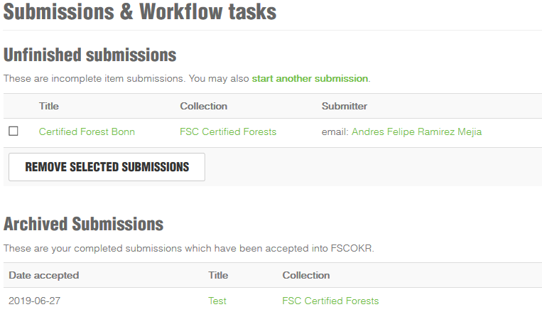

Appendix 1: GIS data structure and template

In order to maintain data integrity, all the geographic data uploaded must comply with the structure defined in the provided template.
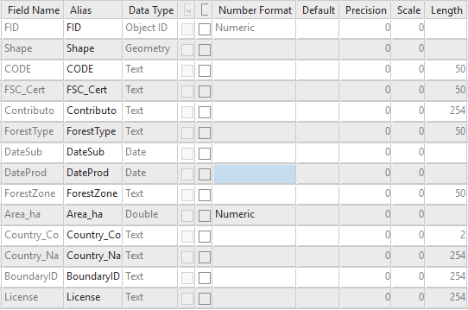

Where:
FID: ObjectID. Automatically generated by any GIS Software. (Do not Modify)
Shape: Geometry field. Automatically generated by any GIS Software. (Do not Modify!)
CODE: Organization internal code if it exists, if not, leave empty.
FSC_Cert: FSC Certification code (i.e. NC-FM/COC-012345, FC-FM/COC-67890, GFA-FM/COC-000000).
Contributo: Certified Organization
ForestType: Type of forest belonging to the MU (i.e. Natural Forest, Plantation)
DateSub: Date of Submission of the geographic file / Map.
DateProd: Date of production of the geographic file / Map.
ForestZone: Zone where the forest belongs to (Boreal, Temperal)
Area_ha: Certified Area reported by the CB/CH
Country_Co: is the ISO 3166 two-letter country codes (https://en.wikipedia.org/wiki/ISO_3166-1_alpha-2#Current_codes)
Country_Na: Name of the country. Must match the Country Code.
BoundaryID: Only for internal use (Do not Modify!)
License: License grantee (i.e. FSC Russia, FSC Canada)

A successful record should look as follows:

